**Experiment No. 03**

**Aim: To implement various kinds of functions in Python.**

**Code:**

**Tuple**

tup = ('apple', 'banana', 'cherry', 24, 656, True, 'apple')

print(len(tup))

print(tup.index('apple'))

print(tup.count('apple'))

st = (2,5,9,3,88,14,4,1,10,111,6,8,7,-27)

aft = sorted(st)

print('Sorted tuple: ', aft)

print(max(st))

print(min(st))

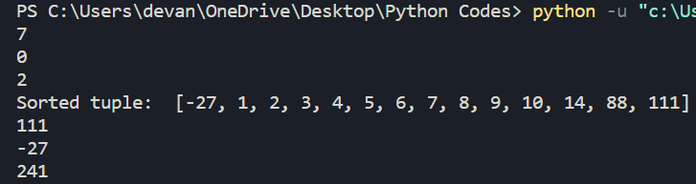print(sum(st))

**Set**

myset = {1, 56, 99, 32, 'were', 'of', 'r', 'u' }

print(myset)

myset.add('save')

print(myset)

myset.discard('of')

myset.discard(6)

print(myset)

myset.pop()

print(myset)

myset.remove(1)

print(myset)

myset.clear()

print(myset)

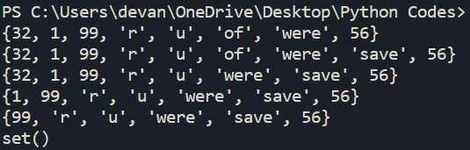**Dictionary**

dict = {1:'a', 2:'b', 3:'c', 4:'d', 5:'e'}

dicta = dict.copy()

print(dicta)

dict3 = (1,2,4)

print(dict.fromkeys(dict3,'as'))

print('Key 3 has value: ', dict.get(3))

dict.pop(2)

print(dict)

dict.clear()

print(dict)

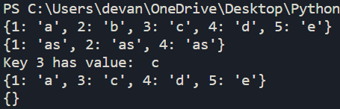

**Anonymous Function**

a=int(input('Enter a number:'))

b=int(input('Enter a number:'))

maximum = lambda a,b:a if a> b else b

print(f'{maximum(a,b)} is a maximum number')

